Report
Of

INTERN APP: A MANAGING DATABASE RECORDS

Submitted To

School of Computer Science and Engineering
IILM University, Greater Noida, U.P.

In partial fulfilment of the requirement of degree of

B.Tech CSE


By
Roll Number of Student: 2410030774
Name of Student: Ikshu Goel
Batch: 2026-27

CANDIDATE'S DECLARATION

I, Ikshu Goel , do hereby declare that the internship report titled “INTERN APP: A MANAGING DATABASE RECORDS” has been completed by me to fulfil the requirement for the award of the degree of Bachelor of Technology in CSE. All the references have been quoted and I have not taken as such any material from any other source. I affirm to you that this report is my own and has not been submitted to any other institute for any degree/diploma requirement and further I shall be solely responsible for any kind of copyright violation in this regard.

Signature
Student Name: Ikshu Goel
Roll No.: 2410030774

ACKNOWLEDGEMENT
I am using this opportunity to express my gratitude to everyone who supported me throughout this project. I am thankful for their aspiring guidance, invaluably constructive criticism and friendly advice during this work. I am sincerely grateful to them for sharing their truthful and illuminating views on a number of issues related to this work.
I express my gratitude to my parents for their blessings.

Signature
Student Name: Ikshu Goel
Roll No.: 2410030774

INTERNSHIP COMPLETION CERTIFICATE

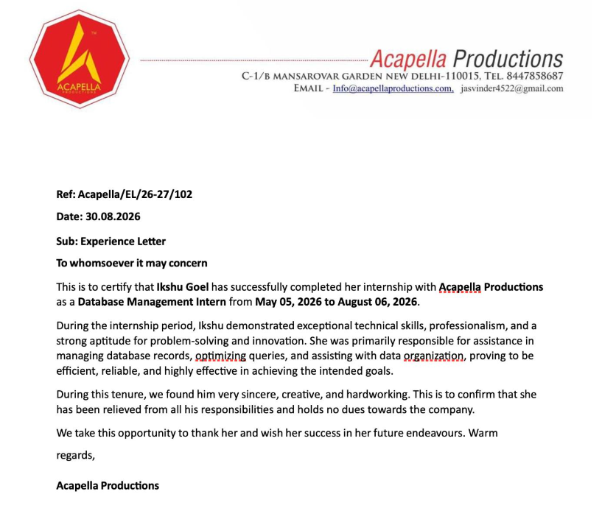

TABLE OF CONTENTS

Chapter No. | Chapter Name | Page Nos.
 | Cover Page
1. | Candidate's Declaration
2. | Acknowledgement
3. | Internship Completion Certificate
4. | Project Description  - Introduction  - Organization / Institution Profile  - Problem Statement  - Project Objectives  - Scope of the Project  - Technologies and Tools Used  - System Architecture  - Methodology  - Expected Outcomes  - Certificates of completion and other communication mail proof
5. | Bibliography / References

- PROJECT DESCRIPTION

Introduction
The internship project was carried out at Acapella Productions as part of the role of a Database Management Intern. The internship was conducted from 05 May 2026 to 06 August 2026. During this period, the primary focus was on understanding and assisting with database-related activities, including management of database records, optimization of queries, and organization of data.
Database management plays an important role in ensuring that organizational data is stored systematically, accessed efficiently, and maintained accurately. The project provided practical exposure to database-related operations and helped in understanding how structured data can be managed to support organizational requirements.
The internship also provided an opportunity to develop technical skills, problem-solving abilities, professionalism, and an understanding of practical database management activities in an organizational environment.

Organization Profile

Acapella Productions is the organization where the internship was undertaken. The internship was completed under the designation of Database Management Intern.
During the internship, the work was primarily related to database management activities. The responsibilities included assisting in managing database records, optimizing queries, and organizing data efficiently. The organization provided an environment in which practical exposure to database-related tasks and professional working practices could be gained.
The internship experience helped in understanding the importance of systematic data management and efficient access to information in an organizational setting.

Problem Statement
Organizations generate and maintain a large amount of information that needs to be stored, organized, accessed, and maintained efficiently. Improper organization of database records can make data retrieval difficult and may affect the efficiency of database operations.
Therefore, the major problem addressed during the internship was to assist in maintaining and organizing database records efficiently while improving the effectiveness of database queries. The project focused on supporting database-related activities through proper data organization and query optimization.
The work aimed to contribute towards efficient data management and reliable access to required information.

Project Objectives
The major objectives of the internship project were:
- To understand the fundamentals and practical applications of database management.
- To assist in managing and maintaining database records.
- To organize data in a systematic and efficient manner.
- To understand and assist in optimizing database queries.
- To improve the efficiency of data retrieval and database operations.
- To develop practical problem-solving skills related to database management.
- To gain professional experience in working with organizational data.
- To understand the importance of accuracy, reliability, and systematic data management.

Scope of the Project

The scope of the project primarily covers database management and organization of records within the organizational environment.

The major areas covered include:

Management and maintenance of database records.

Organization of data for efficient access and retrieval.

Assistance in optimizing database queries.

Understanding database-related operations and workflows.

Identification and resolution of basic data-management-related problems.

Improving the efficiency and reliability of database operations.

The project provides a foundation for further work in areas such as database administration, database optimization, data analytics, and backend development.

Technologies and Tools Used

The internship primarily involved database management activities. The technologies and tools used or relevant to the project included:

Database Management System (DBMS): Used for storing, managing, and retrieving structured data.

SQL Queries: Used for interacting with database records and performing data-related operations.

Database Records: Managed and organized according to organizational requirements.

Query Optimization: Applied to improve the efficiency of database operations and data retrieval.

Data Organization Techniques: Used to maintain structured and easily accessible information.

The internship provided practical exposure to database-related concepts and their application in an organizational environment.

System Architecture

The overall architecture of the database management project can be represented through the following basic flow:
User / Application → Database Query → Database Management System → Database Records → Retrieved / Updated Data
The user or application initiates a database operation. The corresponding query is processed by the Database Management System (DBMS), which accesses the required database records. The requested information is then retrieved and provided to the user or application. Similarly, when data needs to be added or updated, the database processes the operation and stores the updated information.
Query optimization helps improve the efficiency of this process by ensuring that database operations are performed effectively.

Methodology
The project methodology followed a systematic approach to understand and perform database management activities.

Step 1: Understanding Requirements
The database-related requirements and existing records were understood to determine how information needed to be managed and organized.

Step 2: Database Record Management
Database records were reviewed and managed according to the requirements. Proper organization of records was emphasized to make information easier to access and maintain.

Step 3: Data Organization
The available data was organized systematically so that records could be maintained efficiently and retrieved when required.

Step 4: Query Analysis
Database queries were studied to understand their purpose and execution. Queries requiring improvement were analyzed from an efficiency perspective.

Step 5: Query Optimization
Efforts were made to optimize queries to improve the efficiency of database operations and data retrieval.

Step 6: Testing and Verification
Database-related operations were checked to ensure that records were being managed and retrieved correctly and that the intended results were achieved.

Step 7: Documentation
The activities performed and the knowledge gained during the internship were documented as part of the internship project

Expected Outcomes
The expected outcomes of the project were:
- Efficient management and organization of database records.
- Improved understanding of database management concepts and practical operations.
- Better efficiency in database query processing and data retrieval.
- Systematic organization of organizational data.
- Development of practical problem-solving skills.
- Improved understanding of the importance of accurate and reliable data management.
- Gaining practical experience in working as a Database Management Intern.
- Development of professional and technical skills applicable to future database and software development project

4.11 BIBLIOGRAPHY / REFERENCES

• Elmasri, R., & Navathe, S. B. (2016). Fundamentals of Database Systems (7th ed.). Pearson Education.
• Silberschatz, A., Korth, H. F., & Sudarshan, S. (2019). Database System Concepts (7th ed.). McGraw-Hill Education.
• Connolly, T., & Begg, C. (2015). Database Systems: A Practical Approach to Design, Implementation, and Management (6th ed.). Pearson.
• Date, C. J. (2004). An Introduction to Database Systems (8th ed.). Pearson Education.
• Ramakrishnan, R., & Gehrke, J. (2003). Database Management Systems (3rd ed.). McGraw-Hill.
• Microsoft. SQL Documentation and Database Concepts. Microsoft Learn.
• Oracle Corporation. MySQL Documentation. Oracle Documentation.
• PostgreSQL Global Development Group. PostgreSQL Documentation. PostgreSQL Official Documentation.
• Acapella Productions. Internship Experience Letter, dated 30 August 2026. This document confirms the internship role as Database Management Intern and the activities involving database records, query optimization, and data organization.

